ISELCONNECT: A Power Outage and Visual Maintenance Reporting System

A Capstone Project
Presented to the Faculty Members of the
College of Computing Studies, Information, and Communication Technology
ISABELA STATE UNIVERSITY
Echague, Isabela

In Partial Fulfillment of the
Academic Requirements for the Degree
Bachelor of Science in Information Technology (BSIT)
With Specialization Track in Web and Mobile Application Development

By:
BALISACAN, MARK JUSTIN F.
BINUYA, JOHN LLOYD A.
REYES, ALLYSA B.
August 2026
CHAPTER I
INTRODUCTION
1.1 Project Context
Electricity plays a vital role in supporting daily life, economic activities, and public services. In the Philippines, electric cooperatives serve as the primary providers of power, especially in rural and developing areas. However, despite its importance, power interruptions remain a persistent issue that affects productivity, service delivery, and community well-being. According to the Philippine Institute for Development Studies (2022), electricity supply interruptions continue to impact both households and businesses, highlighting the need for more efficient and responsive utility systems.
At present, many electric cooperatives still rely on traditional methods in handling outage reports and maintenance concerns, such as phone calls, walk-in complaints, and paper-based documentation. These manual processes often result in delays, miscommunication, and difficulty in tracking recurring issues. Studies have shown that such inefficiencies in operations remain a challenge among electric cooperatives in the country, limiting their ability to provide timely and effective services (Bautista & Valderrama, 2012). Furthermore, manual monitoring and reporting systems are prone to errors and inefficiencies, which can negatively affect the reliability of power distribution services (International Conference on Power Systems, 2023).
The Isabela-1 Electric Cooperative, Inc. (ISELCO-1), established in 1972, serves 2 cities and 13 municipalities in southern Isabela with over 245,000 consumers. While the cooperative utilizes GPS mapping for infrastructure such as poles and meters, the reporting and monitoring of outages and maintenance issues are still handled manually through calls and personal reports. Despite having sufficient manpower, this traditional approach may lead to slower response times and limited data analysis capabilities.
This situation highlights a significant gap: the absence of a centralized, real-time, and user-friendly system for reporting outages and infrastructure concerns. Without such a system, it becomes difficult to efficiently collect, manage, and analyze data, as well as identify recurring problems in specific areas. Recent studies also emphasize that electric cooperatives face challenges in adopting digital systems for efficient data handling and service management (Cristobal & Santiago, 2025).
To address this gap, the researchers proposed ISELCONNECT, which was designed to facilitate outage notifications and damage reporting. The system provided a centralized and secure platform where consumers could easily report issues and receive timely updates. It was designed with digital inclusion in mind, offering a simple interface, intuitive navigation, and bilingual support (English and Tagalog) to ensure accessibility. In addition, the system incorporated descriptive data analysis to identify common issues across different locations, enabling better decision-making and proactive maintenance.
The implementation of ISELCONNECT was expected to improve communication between the cooperative and its consumers, reduce response time, and enhance overall service efficiency. Moreover, addressing these challenges was crucial, as frequent power interruptions had been shown to result in economic losses and reduced public service performance (Philippine Institute for Development Studies, 2024). By digitizing the reporting and monitoring process, the system could contribute to improved infrastructure management and increased consumer satisfaction, ultimately supporting the modernization of electric utility services. For the typical ISELCO-1 consumer, this often meant waiting in uncertainty during a blackout, unsure if the cooperative was even aware of the specific line fault in their neighborhood.
Statement of the Problem
Currently, some residents often remain uninformed about scheduled or emergency power outages, leaving them unable to prepare essential emergency tools or charge devices. During severe weather, electrical infrastructure like poles and wires are frequently damaged, but these issues often remain unknown to utility linemen because there is no digital way for the residents to report them. Research indicates that traditional, manual reporting methods in utility management lead to significant "situational blindness," where the utility provider is unaware of the exact state of the grid during emergencies (Havas et al., 2017). ISELCO-1 currently lacks a specialized software or system dedicated to tracking these maintenance reports. This delay in reporting allows damage to worsen and significantly slows down the restoration of electricity. Studies suggest that without a timely feedback loop from residents, the time required to identify and verify infrastructure damage can extend from hours to days, directly impacting the economic and social well-being of the affected community (Callaghan, 2016).
The implementation of ISELCONNECT involved modernizing ISELCO-1’s existing manual processes, which relied on physical letters to local officials and Facebook posts that often became buried in social media feeds. The proposed solution introduced a centralized web admin dashboard for ISELCO-1 management to track reported damages and manage outage schedules in real-time. Unlike the previous methods, where linemen had to rely on vague verbal landmarks to locate issues, residents were able to capture live photos through their mobile application and transmit GPS coordinates of damaged poles or sparking wires directly to the agency. Through this hybrid system, the agency could immediately visualize the exact location and severity of the damage, replacing “situational blindness” with data-driven dispatching.
1.2 Objectives of the Project
The primary objective of this project was to design, develop, and implement a user-friendly system that streamlined and improved the reporting and dissemination of power interruption and maintenance information for Isabela-1 Electric Cooperative, Inc. (ISELCO-1).
Specifically, this project aimed to:
1.2.1 Design and develop ISELCONNECT with dedicated modules that enabled the:
- 1.2.1.1 Administrators to: monitor field activity logs, manage system accounts, categorize report types, and generate reports for monitoring purposes.
- 1.2.1.2 Branch Administrators to: monitor lineman availability and assign available linemen to reported concerns during their designated work hours.
- 1.2.1.3 Linemen to: receive assigned maintenance tasks, record work status updates (e.g., Assigned, In-progress, Resolved), and utilize integrated mapping for precise navigation to reported locations.
- 1.2.1.4 Residents to: submit infrastructure damage reports with mandatory live photo capture and GPS geotagging, view their reporting history, and receive targeted power advisories.

1.2.2. Evaluate the system compliance as to ISO/IEC 25010 system quality evaluation metrics:
1.2.2.1 Functional Suitability
1.2.2.2 Performance Efficiency
1.2.2.3 Compatibility
1.2.2.4 Interaction Capability
1.2.2.5 Reliability
1.2.2.6 Security
1.2.2.7 Maintainability
1.2.2.8 Portability
1.3 Scope and Limitations
This study focused on the design and development of ISELCONNECT, a centralized web and mobile-based system intended to improve the reporting, monitoring, and dissemination of power outage and infrastructure-related concerns for Isabela-1 Electric Cooperative, Inc. (ISELCO-1). The system supported three (4) user roles: Administrator, Branch Administrator, Linemen, Resident.
The Administrator manages and oversees all system operations, including creating and managing lineman accounts, validating resident reports, assigning tasks to linemen, monitoring report progress, and generating reports for monitoring purposes.
The Branch Administrator is responsible for assigning available linemen to reported concerns during their designated work hours. The Branch Administrator monitors the availability of linemen and assigns appropriate personnel based on their availability and the reported concern.
The Linemen act as field personnel responsible for responding to assigned reports. They receive task assignments, review the technical details and locations of reported issues, and perform on-site inspection and repair. They also provide status updates such as “Assigned,” “In-progress,” and “Resolved,” and submit photos and remarks as proof of completed work prior to the closure of the report.
The Residents are the end-users of the system and were responsible for submitting digital reports regarding power interruptions and infrastructure issues such as damaged poles, transformers, or power lines.
The scope of the system includes user registration and validation through OTP authentication, with valid ID and selfie verification during account creation. It also covers targeted notifications for affected barangays, mobile real-time in-app notifications, GPS-tagged and image-based damage reporting, map-based dashboards for monitoring reported concerns, report status tracking, and descriptive analytics for monitoring and decision-making.
However, the system has certain limitations. It relies on internet or cellular connectivity; therefore, users without network access may be unable to receive notifications or submit reports. The system does not include billing and payment functionalities, as these require integration with external systems and third-party APIs. Furthermore, linemen may experience limited functionality in areas with poor or no signal, which may affect real-time updates and synchronization.
1.4 Significance of the project
The development of ISELCONNECT provided significant benefits to various stakeholders involved in the power distribution and reporting system of Isabela-1 Electric Cooperative, Inc. (ISELCO-1).
For the Administrators: The system served as a centralized platform for managing, monitoring, and validating reports. It facilitated efficient report management, provided access to relevant system information, and supported the generation of printable reports for monitoring, documentation, and administrative purposes.
For the Branch Administrators: The system provides a centralized platform for assigning available linemen to reported concerns during their designated work hours. It helps branch administrators monitor linemen availability and assign appropriate personnel based on their availability and the reported concern, improving the coordination and efficiency of field operations.
For the Linemen: The system enhances field operations by providing accurate and verified reports. Because the system mandates live photo capture, linemen are protected from responding to outdated or fraudulent reports. The integrated mapping reduces "vague landmarks," allowing them to navigate directly to the fault, thereby improving their safety and efficiency during emergency repairs.
For the Residents: The system provided a more convenient and secure way of reporting power outages and infrastructure-related concerns through a mobile application. Through OTP authentication, valid ID and selfie verification, and consumer-name validation, residents were provided with a secure and validated registration process. Furthermore, the targeted notification system provided relevant and localized updates to residents within affected barangays regarding scheduled maintenance and emergency outages.
For ISELCO-1: ISELCONNECT modernizes the cooperative's image and operations by shifting from manual, paper-based, and social-media-dependent communication to a professional, real-time digital system. This reduces operational costs, minimizes communication gaps, and ultimately increases consumer trust and satisfaction.
For Future Researchers: This study provides a specialized framework for integrating geolocation, real-time status tracking, and mobile-web hybrid architecture in the context of rural utility management in the Philippines, serving as a baseline for future digital transformation projects in the power sector.

CHAPTER III
RESEARCH METHODOLOGY
This chapter details the research methods and procedures used for the development of ISELCONNECT. The content covers the research design, system development method, participants, data gathering instruments, evaluation procedures, and data analysis techniques employed by the researchers.
3.1 Research Design
This study employed a Developmental Research Design guided by the Rapid Application Development (RAD) model, complemented by a Descriptive Research Approach. These approaches were selected to support the study's primary objective of systematically designing, developing, and implementing a comprehensive, accessible, and user-centered platform for ISELCO-1.
The research was descriptive as it sought to document existing operational gaps, manual dispatching, and the absence of immediate tracking capabilities identified during the initial feasibility phase. It was developmental as it focused on the creation of a working digital solution specifically a centralized web application for management and a responsive mobile application for Residents and Linemen to bridge the communication gap between the utility provider and the community.
3.2 System Development Method
The researchers adopted the Rapid Application Development (RAD) model. According to MaybeWorks (n.d.), this methodology allowed the team to transform manual reporting challenges into a high-performance digital solution within a condensed timeframe.
The selection of the RAD model is supported by existing literature regarding utility management and emergency response. Research by Havas et al. (2017) indicates that traditional, manual reporting methods in utility management lead to significant "situational blindness," where providers remain unaware of the exact state of the grid during emergencies. Furthermore, Callaghan (2016) suggests that without an immediate feedback loop from residents, the time required to identify and verify infrastructure damage can extend from hours to days. By utilizing an agile, iterative approach like RAD, the team will implement the concept of "citizens as sensors" as explored by Chaves et al. (2019), where crowdsourced visual data provides a cost-effective and high-speed alternative to traditional sensor networks in rural areas.
RAD was particularly effective for this project because it emphasized iterative prototyping and active stakeholder feedback over rigid planning. This approach ensured that the "Elder Friendly Interface" and GPS-integrated features underwent constant refinement through continuous user evaluation before final deployment.

Figure 1. The Rapid Application Development (RAD) Lifecycle for ISELCONNECT
https://maybe.works/blogs/rapid-application-development-rad
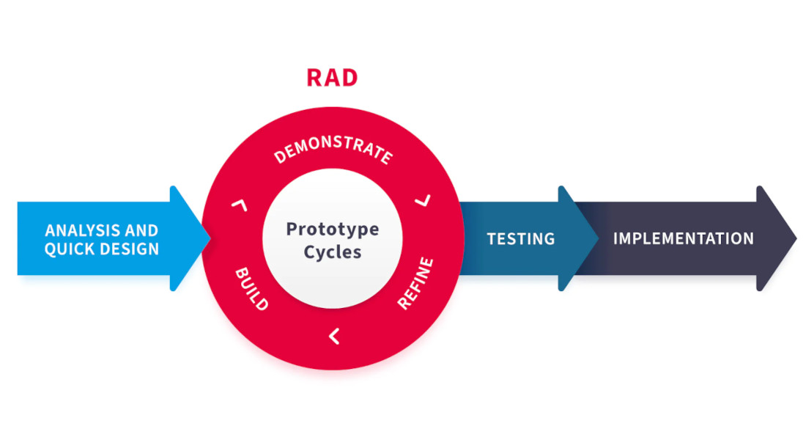
Figure 1 RAD allowed the researchers to continuously refine system features for both the web and mobile component. The methodology consists of four phases that ensured the system met its functional requirements and operated effectively in supporting digitalized motor vehicle offense management for ISELCO-1.

Phase 1: System Setup and Design Finalization

During this phase, the researchers finalized the system’s overall user interface (UI) design, focusing on creating a simple, organized, and user-friendly layout for both web and mobile access. The database structure was established to efficiently manage users, reports, maintenance tasks, outage schedules, and system records. Development tools and frameworks necessary for building the system were installed and configured. Additionally, initial integration setups such as API configurations, notification services, GPS functionality, and device compatibility for core system features were completed to prepare for full-scale development.

Phase 2: System Development

This phase involved the actual construction of the system’s core modules and functionalities. Key components developed during this stage included the administrator dashboard for monitoring, descriptive analytics, and report management; the resident account creation, reporting module for submitting infrastructure damage reports; and the lineman module for receiving assigned tasks, viewing report locations, and updating work status. The system also integrated GPS-based location tracking, live photo capture, mapping features, and notification services to support reporting, dispatching, and communication. Initial testing sessions were carried out with selected users to gather feedback, which guided early refinements.

Phase 3: Testing and Refinement
In this phase, the system was tested by the researchers, their adviser, and selected classmates to identify and fix performance and functionality issues through load testing, stress testing, and compatibility testing. Feedback from the testers was reviewed, and the system’s features and design were improved accordingly. A second round of testing was planned to be conducted after the prototype presentation to further validate the system’s functionality and confirm its readiness for deployment.
Phase 4: Deployment
The final system will be implemented and made fully operational. Training will be provided for ISELCO-1 staff and linemen to ensure proper use of the system and a smooth transition from the manual reporting process.
3.3 Participants/Respondents
The study targets three (3) primary stakeholder groups to ensure that the system meets real-world requirements. These groups include the ISELCO-1 24/7 Management, IT Department, and Branch Administration, represented by three (3) IT experts; ten (10) Linemen, who are responsible for technical repairs and field updates; and ten (10) Residents within the service area, who report issues and receive notifications. The researchers propose a convenience sampling method to select the participants who will evaluate the system. The three (3) IT experts will evaluate the technical aspects and functionality of the system, while the Linemen and Residents will assess the system's practical use and user experience based on their respective roles.
3.4 Data Gathering Instrument
The researchers will utilize several measures to gather the required and pertinent data needed in the research.
Survey: Systematic survey will collect quantitative information from the prospective IT personnel, linemen, and residents. The survey will include closed-ended questions to evaluate their level of awareness, interest, and expectation regarding power outage and visual maintenance report. The survey will be administered both online through Google Form.
Questionnaires: Along with surveys, questionnaires will also be designed specifically for specific groups like, residents of the local area, IT personnel, and linesmen. In this way, their perspective will be developed and assist the needs.
Online Library Research: A comprehensive digital literature search on power outage report and crowdsource report will be conducted via scholarly databases and electronic library resources. This approach will secure factual data and background information regarding the historical, cultural, and environmental origins unique to the study
3.5 Evaluation Procedure
The researchers will conduct a comprehensive evaluation of the completed system to assess its overall performance and compliance with established software quality standards. This procedure will consist of two major components: system testing and system evaluation based on international quality metrics.
First, the system’s performance will be tested using load testing, stress testing, and compatibility testing. Load testing will be performed to determine how the system handles multiple users simultaneously, while stress testing will identify the system’s limits under extreme conditions. Compatibility testing will ensure that the system functions properly across different devices, operating systems, and browsers. These tests aim to verify the stability, responsiveness, and adaptability of the system in real-world usage scenarios.
Following the performance testing, the system will be evaluated based on the ISO/IEC 25010 system quality model. Selected participants, including IT professionals, utility personnel, and residents, will use the system and assess it through a structured questionnaire. The evaluation will focus on key quality characteristics such as functional suitability, performance efficiency, compatibility, interaction capability, reliability, security, maintainability, and portability.
The collected data will be analyzed to determine whether the system meets the required standards and user expectations. The results of this evaluation will serve as the basis for further improvements, ensuring that the final version of the system is efficient, reliable, secure, and user-friendly for its intended users.
3.6 Data Analysis Techniques
The 5-point Likert scale and its mean score interpretation (e.g., 4.21–5.00 = Strongly Agree) are commonly employed in survey research to quantify respondents’ attitudes and perceptions (International Journal of Scientific Advances, 2022; Boone & Boone, 2012).
Table 1. Likert Scale (Bertram, 2016)
https://cspages.ucalgary.ca/~saul/wiki/uploads/CPSC681/topic-dane-likert.pdf
Scale | Range | Qualitative Rating
5 | 4.21 – 5.00 | Strongly Agree
4 | 3.41 – 4.20 | Agree
3 | 2.61 – 3.40 | Undecided
2 | 1.81 – 2.60 | Disagree
1 | 1.00 – 1.80 | Strongly Disagree

Table 1 outlines the scoring system the researchers use to interpret the survey results. It defines the numerical ranges for the weighted mean alongside their corresponding qualitative ratings to ensure a clear and standardized analysis of participant feedback.
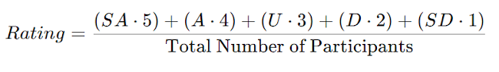
Where:
Rating = Total result of evaluation
SA = Total number of participants who answer Strongly Agree
A = Total number of participants who answer Agree
U = Total number of participants who answer Undecided
D = Total number of participants who answer Disagree
SD = Total number of participants who answer Strongly Disagree

CHAPTER IV
TECHNICAL BACKGROUND
4.1 Introduction
This presented the comprehensive technical framework and logical design of ISELCONNECT to revolutionize utility maintenance and power outage reporting for ISELCO-1. This chapter served as the technical blueprint for the proposed system, bridging the gap between the identified problem and a robust, scalable digital solution.
Additionally, this chapter outlined the Design Considerations for security and scalability, provided User Interface Mock-ups that illustrated a user-centric experience for both elderly residents and field workers, and presented formal System Diagrams (Context, DFD, and ERD). These diagrams provided a rigorous mapping of the system’s data flows and relational structure, ensuring that every crowdsourced report was accurately localized, traceable, and resolved through a transparent, automated workflow.
4.2 System Architecture
The System Architecture of ISELCONNECT defined the structural design and technical framework required to support a collaborative reporting environment. It illustrated how hardware, software, and data storage worked together to facilitate rapid communication between all stakeholders.

4.2.1 Overview of System Architecture
The architecture diagram for ISELCONNECT illustrated a setup built to support smooth communication and coordination among Administrators, Linemen, and residents through a cloud-based infrastructure. The architecture was designed to handle immediate data flow, where Administrators used desktop workstations for management and monitoring, while Linemen and residents utilized mobile devices to interact with the platform’s reporting and maintenance features.
This design enabled data exchange, allowing administrators to validate incident reports, dispatch linemen to precise coordinates, and push power advisories to residents. By centralizing data and logic in the cloud, the architecture ensured that all user roles remained synchronized, ultimately improving the operational efficiency and transparency of utility maintenance in the target community.
4.2.2 System Components
The ISELCONNECT System Architecture followed a centralized, API-driven model designed for responsiveness and high data integrity. The architecture bridged the communication gap between the cooperative and the community through an integrated cloud-based ecosystem using Supabase as the primary backend platform.
Supabase Cloud (Backend & API): Acting as the central backend platform of the system, Supabase provided the services required to manage authentication, data processing, API communication, file storage, and real-time updates. It handled requests from the different user roles and facilitated secure communication between the web and mobile applications and the system's data resources.
Supabase PostgreSQL Database: This served as the primary repository for structured system information. It managed user profiles for residents, linemen, administrators, and branch administrators, as well as maintenance reports, outage schedules, task assignments, report statuses, and other system records.
Supabase Media Storage: This component stored visual files submitted through the system, particularly photographs associated with infrastructure damage and completed maintenance work. The database maintained the corresponding file references, while Supabase Storage handled the actual image files.
Internet Service Provider (ISP) & Connectivity: The system utilized internet connectivity to facilitate data exchange between the Supabase cloud platform and the different user applications. Administrators and Branch Administrators accessed the system through web portals using desktop computers, while Linemen and Residents accessed the system through mobile applications using cellular data or Wi-Fi. This connectivity enabled users to submit reports, access assigned tasks, update report statuses, view locations, and receive system notifications.

4.2.3 System Architecture Diagram
Figure 2: System Architecture Diagram
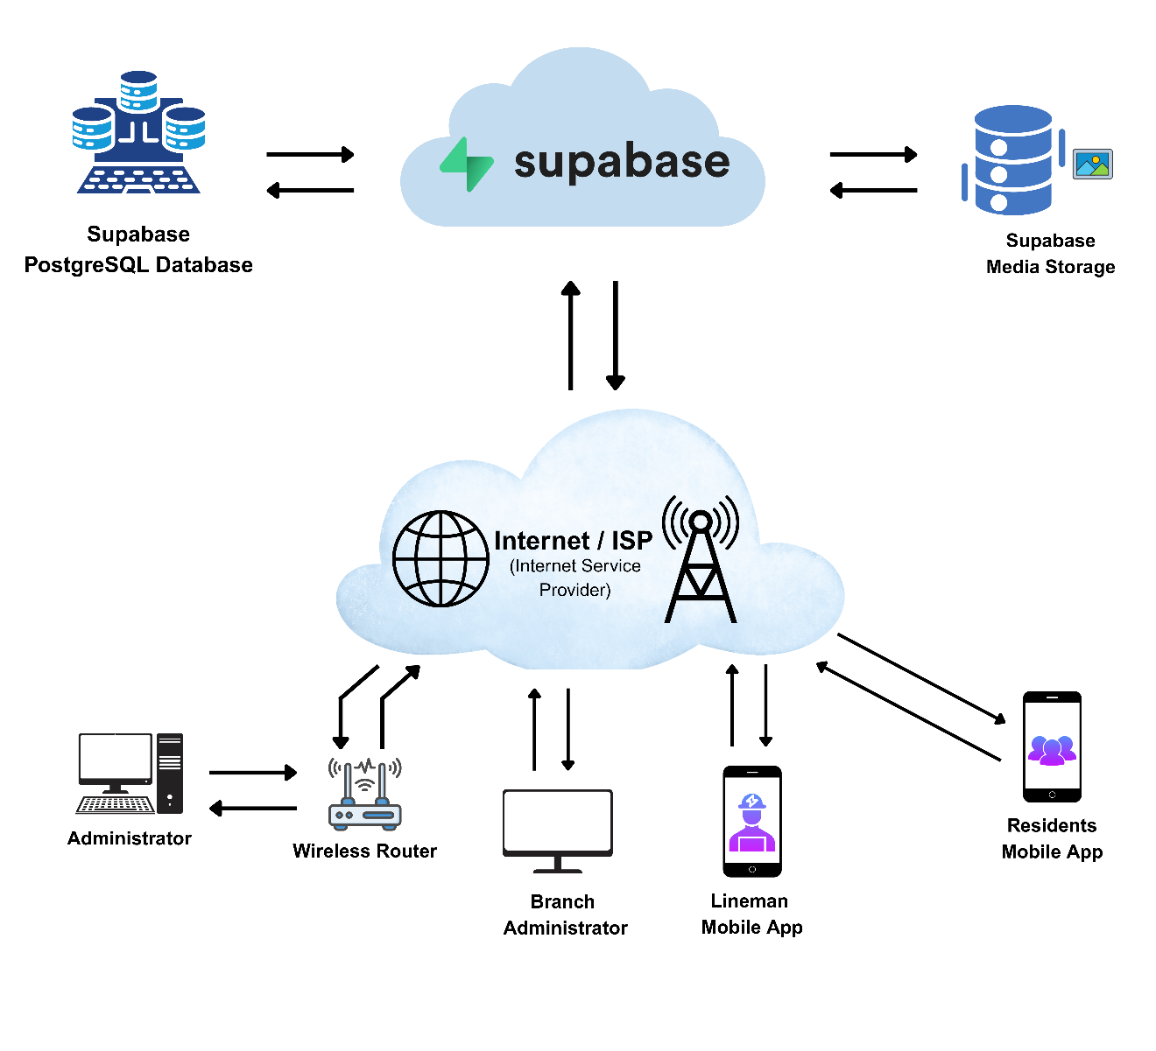
Figure 2 shows the system’s architecture diagram for ISELCONNECT, built to support smooth communication and coordination among Administrators, Linemen, and residents through a cloud-based setup.

4.3 Technologies and Development Tools
The development of the system followed a modern, decoupled architecture designed for high availability and data synchronization. The following software stack was selected to meet the system's requirements for low-latency reporting and cross-platform accessibility.
4.3.1 Programming Language
The proposed system utilized JavaScript as its primary programming language. JavaScript was used for frontend development through Vue.js and React.js to create responsive and interactive user interfaces for both web and mobile platforms, including features such as real-time updates, user interactions, and data handling. For the backend and database services, the system used Supabase, which handled database management, authentication, API integration, and real-time data synchronization. This combination of technologies ensured a structured, scalable, and efficient system architecture that supported seamless communication between the frontend and backend components.
4.3.2 Frontend Frameworks
React Native (Mobile Application): To achieve the objective of providing a responsive mobile tool for both residents and linemen, React Native was employed. This framework allowed for the development of a cross-platform application that delivers native-level performance.
Vue.js (Web Administrator Portal): The administration dashboard was built using Vue.js. Vue’s reactive data-binding system was critical for ISELCO-1’s 24/7 Customer Service, as it allowed the dashboard to update incident markers on the map instantly without requiring a manual page refresh.
4.3.3 Backend Frameworks
The proposed project utilized Supabase as its primary backend platform to manage database operations, authentication, API integration, and real-time data synchronization. To address the critical need for instantaneous communication between residents and utility providers, the system integrated Firebase Cloud Messaging (FCM) for push notifications and an email-based OTP mechanism for user verification.
Once a consumer submitted a visual report through the mobile application, the system sent notifications to the web dashboard and the assigned linemen’s devices. The real-time notification mechanism helped reduce information lag and supported faster utility fault response times through automated alerts. During account registration and verification, the system used email OTP to verify the user's email address and support secure authentication.
4.3.4 Database Management System
Data persistence for the proposed system was managed through a PostgreSQL relational database provided by Supabase, which was integrated with the system's backend services. This database was selected for its support for structured relational data and its efficiency in managing relationships between users, reports, maintenance tasks, outage schedules, and other system records.
The implementation of this database allowed the system to store and manage precise GPS coordinates associated with reported infrastructure concerns, which were visualized using Leaflet maps. By utilizing these location-based capabilities, the system supported the identification and assignment of appropriate linemen based on the location of reported faults. Furthermore, the relational integrity of the database ensured that submitted evidence, email OTP verification records, report histories, task assignments, and status updates remained securely linked to the appropriate geographic and user records.
4.3.5 Development and Collaboration Tools
Integrated Development Environment (IDE): Visual Studio Code was used as the primary coding environment, supplemented by Android Studio for mobile emulation and testing.
Version Control: Git and GitHub were utilized to manage source code iterations and maintain a historical record of system updates.
UI/UX Design and Prototyping: Figma was utilized to design and iterate the user interface of the system. It enabled the development of interactive prototypes that simulated the user journey, allowing early visualization and refinement of system features prior to actual implementation. This approach supported the preparation of the system for subsequent performance testing, including load, stress, and compatibility testing, as well as evaluation based on ISO/IEC 25010 system quality standards.

4.3.6 Hosting / Deployment Platform
Render will be utilized as the unified Platform-as-a-Service (PaaS) to host the server-side logic and API services. Render will manage the execution environment for the backend, providing automated deployment through a Continuous Integration and Continuous Deployment (CI/CD) pipeline linked to the project’s version control system. This will ensure that any technical updates to the outage-handling logic are seamlessly integrated. Render’s infrastructure will provide a secure and scalable environment for managing the communication between the mobile clients and the administrative dashboard.
4.4 Design Considerations
The development of ISELCONNECT was guided by several core design principles to ensure that the system remained reliable, safe, and easy for the entire community to use. These considerations bridged the gap between the technical setup and the project’s goal of providing improved utility services to ISELCO-1 consumers.
4.4.1 Scalability
The proposed system was designed to scale alongside ISELCO-1, which serves over 245,000 consumers. By utilizing a cloud platform such as Render, ISELCONNECT was designed to accommodate increases in concurrent users, particularly during weather events when the volume of reports could increase significantly. The database was organized into normalized tables to reduce data redundancy and maintain data integrity as the volume of reports increased. Furthermore, the decoupled architecture of the web dashboard and mobile application allowed their respective interfaces to be updated independently without necessarily affecting the operation of the other client.
4.4.2 Security
Protecting the private information of residents and the utility's records was a top priority of the project. ISELCONNECT implemented Role-Based Access Control (RBAC) to ensure that only authorized staff could perform specific functions, such as assigning tasks, while residents were restricted to accessing their own reports. All data transmitted between the application and the server was protected through HTTPS encryption to prevent unauthorized interception. To verify the authenticity of resident accounts, the system required users to register using their official information and submit a valid identification document for verification. Additionally, an email-based One-Time Password (OTP) was implemented to verify users during the registration process. Every action performed by an administrator was recorded in a system log to maintain accountability, traceability, and procedural integrity.
4.4.3 Usability
A major goal of the system was to ensure ease of use for all stakeholders, including elderly users and individuals with limited technical proficiency. The mobile application featured a simplified interface with large buttons and clear icons to minimize user confusion. To accommodate diverse user needs, the application allowed users to adjust font sizes and select between English and Filipino language options. By adhering to these user-centered design principles, the system helped reduce delays in accessing and understanding power outage information, particularly among residents with limited technical familiarity.
4.4.4 Performance Efficiency
The system was designed to operate with high responsiveness to support ISELCO-1 in addressing power interruptions efficiently. By utilizing Supabase Realtime, newly submitted reports were displayed on the administrator’s dashboard in near real time without requiring a manual page refresh. The database also utilized spatial data to store and process the precise GPS coordinates of reported incidents and damaged infrastructure, supporting the identification of appropriate linemen for dispatch. To support field operations in areas with limited connectivity, the mobile application incorporated local data persistence, allowing work-related data to be temporarily stored on the device and synchronized with the central server once a stable internet connection was restored.
4.5 User Interface Design
This section presented the visual design and interface specifications of the ISELCONNECT platform. The user interface (UI) was categorized into the Web Administrator Portal and the Mobile Application, each tailored to the specific functional requirements of office staff, field linemen, and resident users.

4.5.1 Hybrid (Web & Mobile Application) Mock-ups
4.5.1.1 Web Application Mock-ups
Figure 3: Dashboard
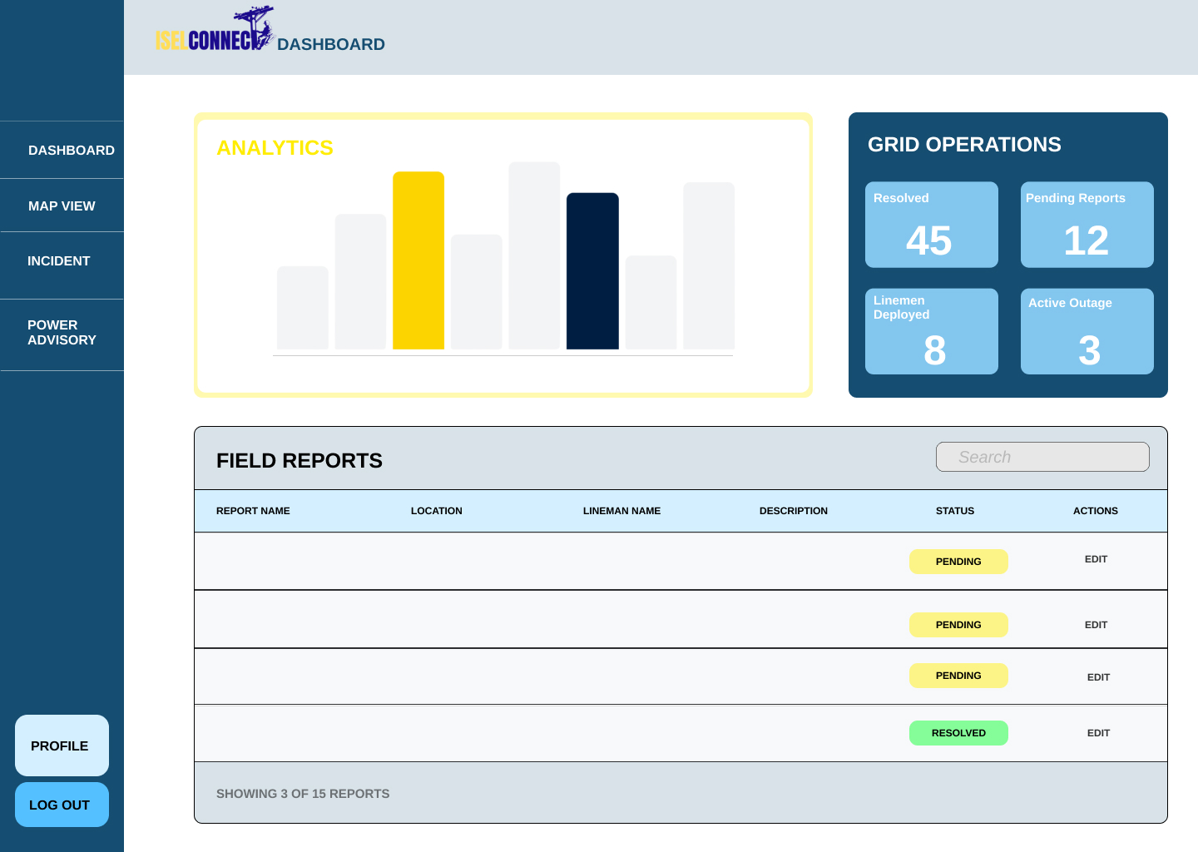
The Dashboard is the first thing the admin sees. It has a section for Analytics with charts that show how many reports are coming in. There is also a Grid Operations box that shows quick numbers, like how many reports are "Pending" and how many linemen are currently working. Below that, a Field Reports list shows the latest problems reported by residents.

Figure 4: Report Management and Assignment
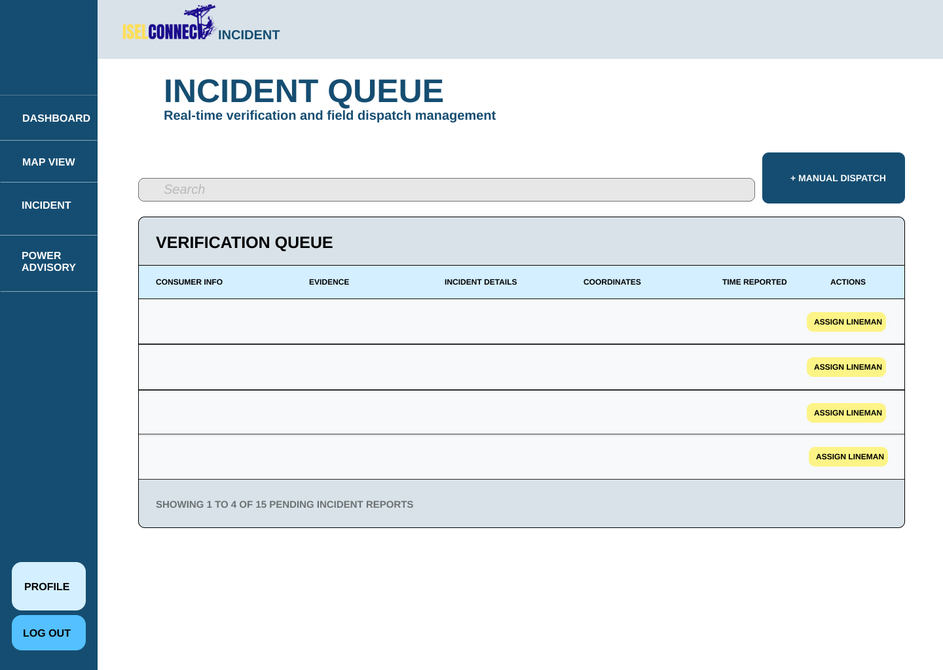
The Incident Queue is where the admin manages the work. It shows a list of reports sent by residents, including photos of the damage and the GPS location. The admin can click the "Assign Lineman" button to choose which worker will go to the site to fix the problem.

Figure 5: Analytics and Map View
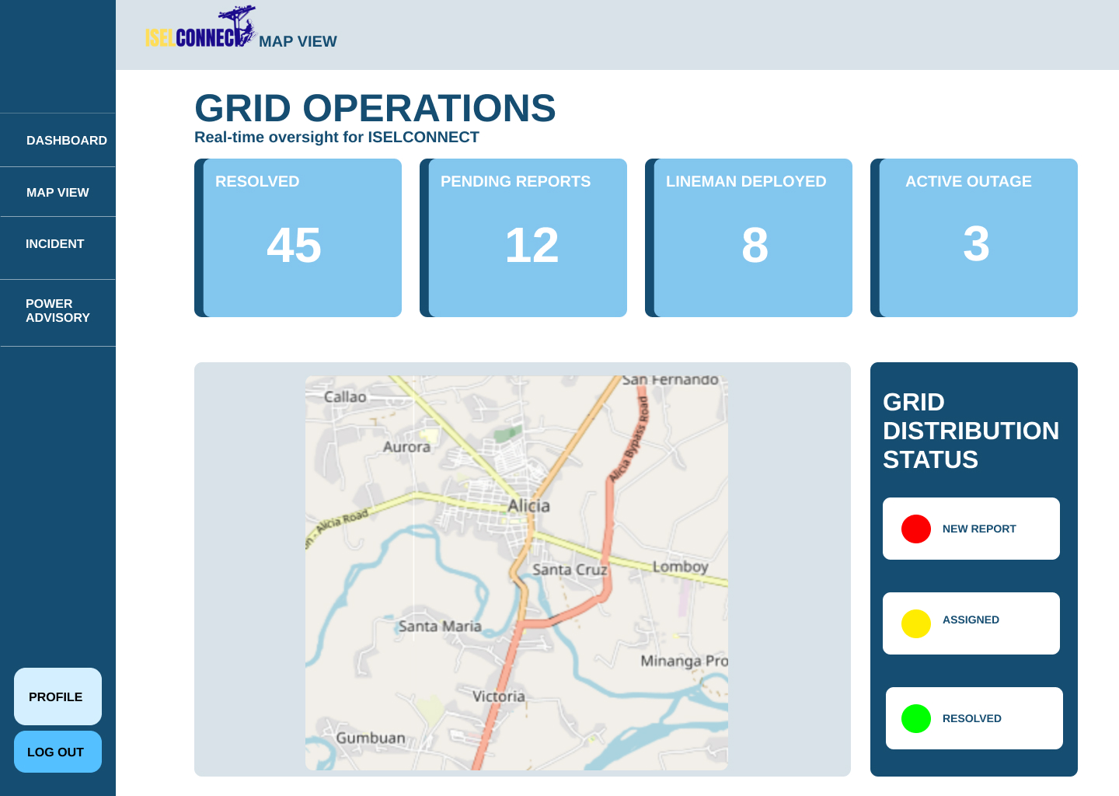
The Map View section is where administrators can see all power problems on a real map. At the top, there are four blue cards under Grid Operations that show live numbers: how many reports are fixed, how many are still waiting, how many workers are out, and how many active outages there are.
On the right side, the Grid Distribution Status uses a simple color code. Red means there is a new report, Yellow means a worker is assigned, and Green means the problem is fixed. This screen helps the office see exactly where the issues are happening so they can send help quickly.

Figure 6: Account Management
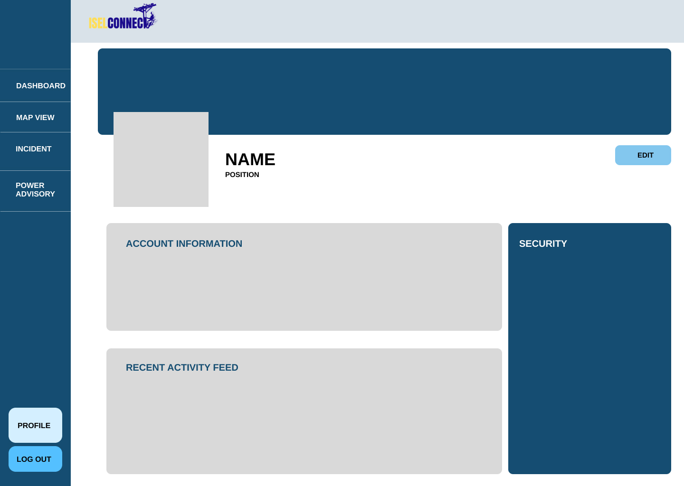
The Profile Screen shows the admin’s name and position. It has an Account Information section where they can update their details and a Security section to change their password. It also shows a Recent Activity Feed so the admin can see a history of the work they have done in the system.

Figure 7: Power Advisory
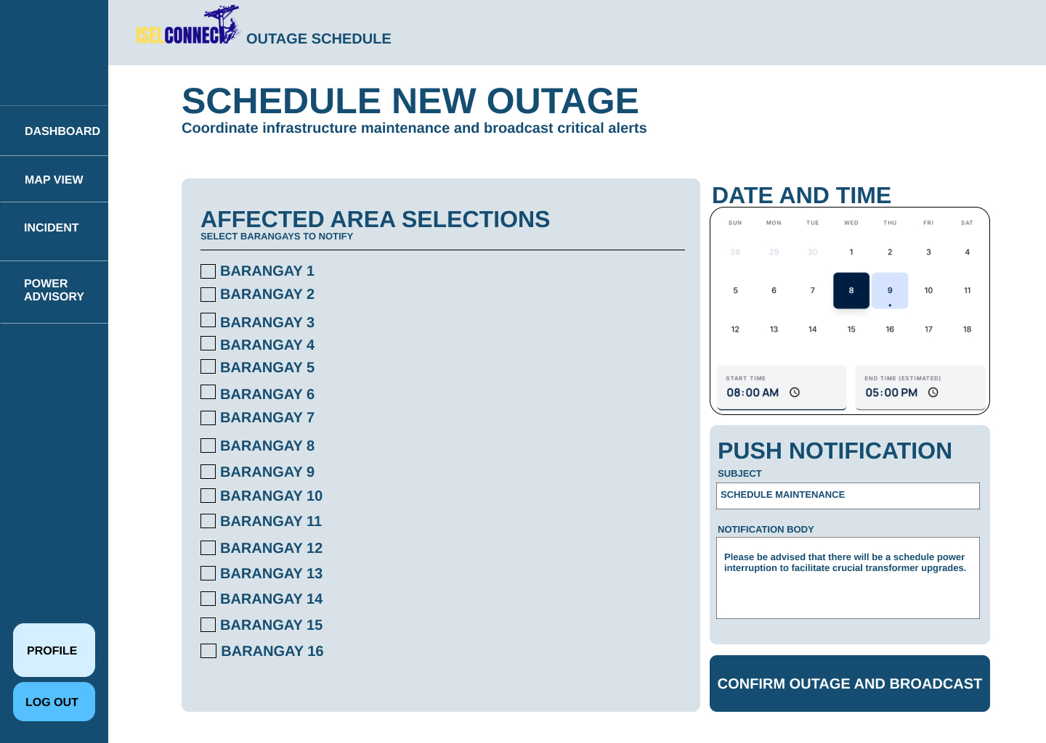
This screen is used to tell people about power cuts. The admin can check boxes for specific Barangays that will lose power. They can set the date and time on a calendar and write a message. When they click "Confirm," the system automatically sends a notification to the mobile phones of the people living in those areas.

Figure 8: Branch Administrator Dashboard
The Branch Dashboard is the first thing the admin sees. It has a section for Analytics with charts that show how many reports are coming in. There is also a Grid Operations box that shows quick numbers, like how many reports are "Pending" and how many linemen are currently working. Below that, a Field Reports list shows the latest problems reported by residents.
Figure 9: Lineman Availability and Assignment
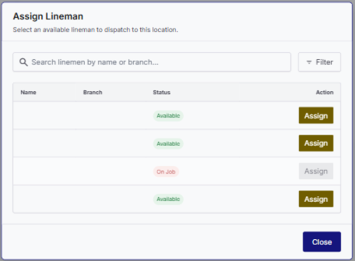
A dedicated modal displaying a searchable and filterable list of branch linemen with real-time status indicators (Available or On Job) to facilitate quick dispatching.

4.5.1.2 Mobile Application Mock-ups
Figure 10: Resident Home Dashboard
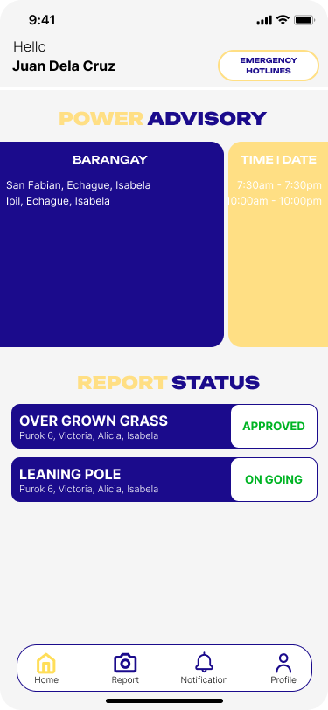
The application has a basic design for everyone to easily understand the application. Upon logging in onto the application it will display the reports that were made by the user.

Figure 11: Resident Damage Report Submission
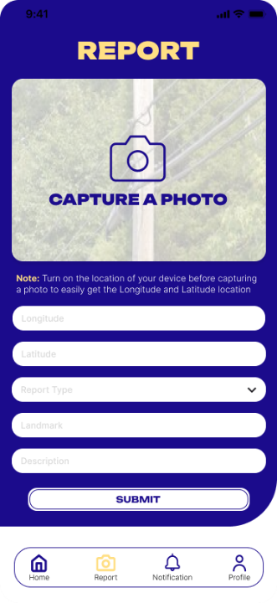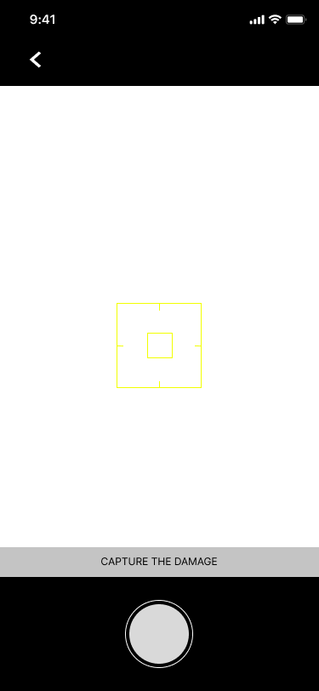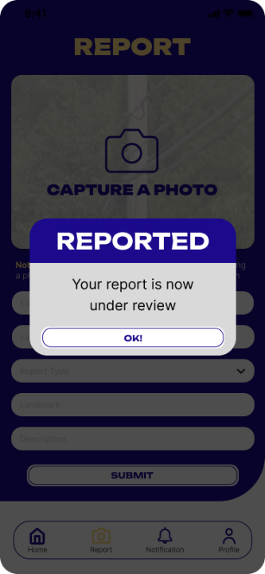
For the report screen, it will first show the report guidelines before allowing the user to report, then the user need to take a picture of the said damage, it will have the geotag of the device to identify the location of the report and the application auto fill the address of the report so that the user only needs to provide the report type and the landmark. When successfully reported the admin will verify the report damage then the application will not allow the user to report again to avoid spamming of reports and they can report once the recent report was approved.

Figure 12: Resident Report History and Tracking
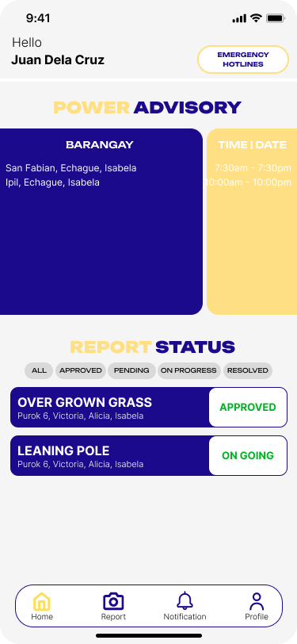
Report History was display at the home tab under “Report Statuses” user can filter the report base on the status of the report by clicking the stat card at the top.

Figure 13: Lineman Assigned Task and Map
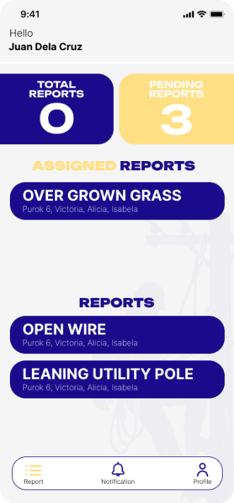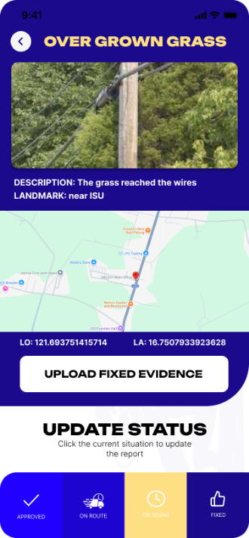
The Lineman user can click on the assigned report to view the information of the report and the map location of the report.

Figure 14: Lineman Work Status and Completion
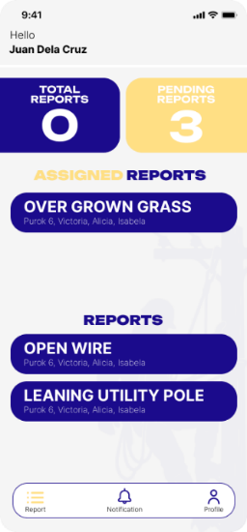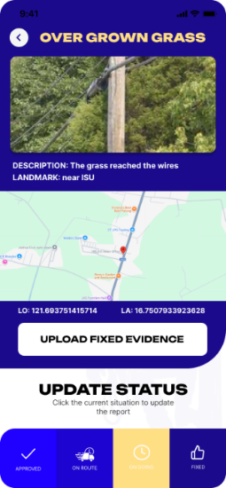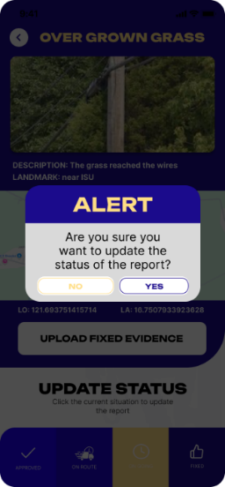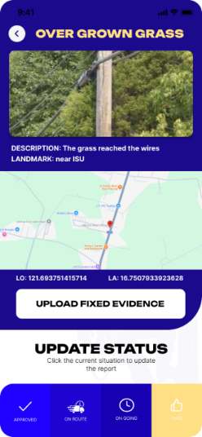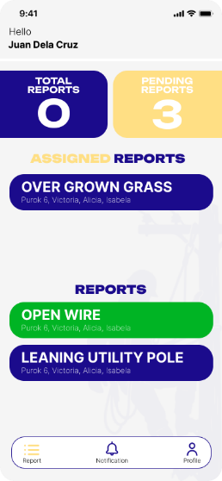
When the assigned report was viewed by the lineman, it will show them the information of the report like the image, description, landmark, address, geotag, and the companions. The lineman can also view the map of the report. When the damage was fixed, the lineman will click the “fixed” button, and it will require the lineman to take a picture of the resolved report and a short remark. When submitted the admin will now verify the report.
4.6 System Diagrams
This section presents the logical and structural models of ISELCONNECT. These diagrams define the boundaries of the system, the flow of information between users and data stores, and the relational architecture of the database, ensuring a transparent and automated utility maintenance workflow.

4.6.1 Context Diagram
Figure 15: Context Diagram of the Developed ISELCONNECT Level 0
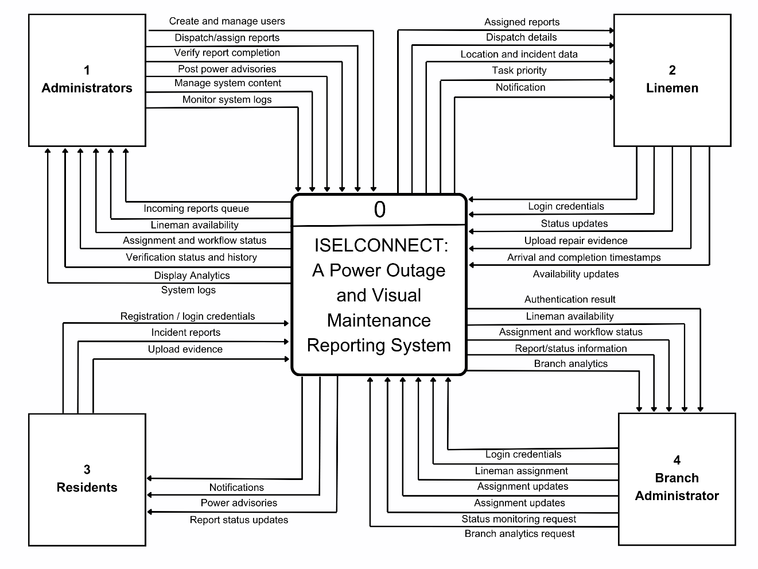
Figure 48 illustrated the context diagram of ISELCONNECT, an Integrated Web and Mobile Application for Immediate Power Outage and Crowdsourced Visual Maintenance Reporting. It identified the system’s primary entities, Administrators, Branch Administrators, Linemen, and Residents and outlined the data exchange between each role and the central process.
The Administrator managed the system by creating and managing users, dispatching and assigning reports, verifying report completion, posting power advisories, managing system content, and monitoring system logs, while receiving an incoming reports queue, lineman availability, assignment and workflow status, verification status and history, display analytics, and system logs in return. The Branch Administrator interacted with the system by providing login credentials, lineman assignments, and assignment updates, while receiving authentication results, lineman availability, assignment and workflow status, report/status information, and branch analytics.
The Lineman interacted with the system to receive assigned reports, dispatch details, location and incident data, task priority, and notifications, while providing login credentials, status updates, uploaded repair evidence, arrival and completion timestamps, and availability updates. Finally, the Resident engaged by submitting registration/login credentials, incident reports, and uploaded evidence, while receiving notifications, power advisories, and report status updates. This diagram reflected the streamlined integration of all stakeholders, ensuring that every reported maintenance task was accurately localized and traceable within the system.

4.6.2 Data Flow Diagram (DFD)
Figure 16: Data Flow Diagram (Administrator) Level 1
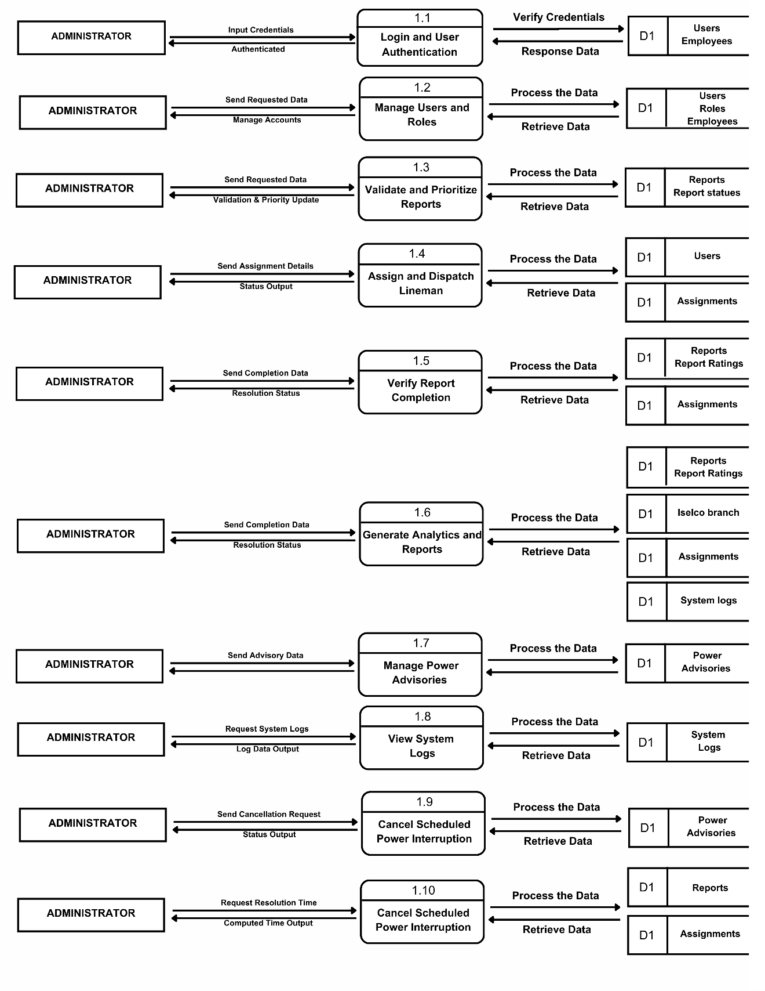
Figure 16 presented the data flow for an Administrator using the ISELCONNECT system. The system allowed the Administrator to log in and manage users, validate and prioritize incoming incident reports, dispatch linemen to specific tasks, and verify the completion of maintenance work. These functions interacted with various data stores (D1), including user credentials, incident reports, task assignments, power advisories, and system logs.
The process began when the Administrator entered their login credentials, which were validated against the Users database. After authentication, the Administrator could manage user accounts and process incoming maintenance requests by querying the Reports database to set priority levels. Once validated, the Administrator dispatched linemen by submitting details to the Assignments database. After the work was finished, the Administrator reviewed the results to verify completion and provide necessary remarks. The Administrator also monitored system integrity by generating analytics, posting power advisories, and viewing activity through the System Logs. This flow highlighted how the Administrator played a central role in ensuring accurate data handling, effective maintenance management, and staff oversight.

Figure 17: Data Flow Diagram (Lineman) Level 2
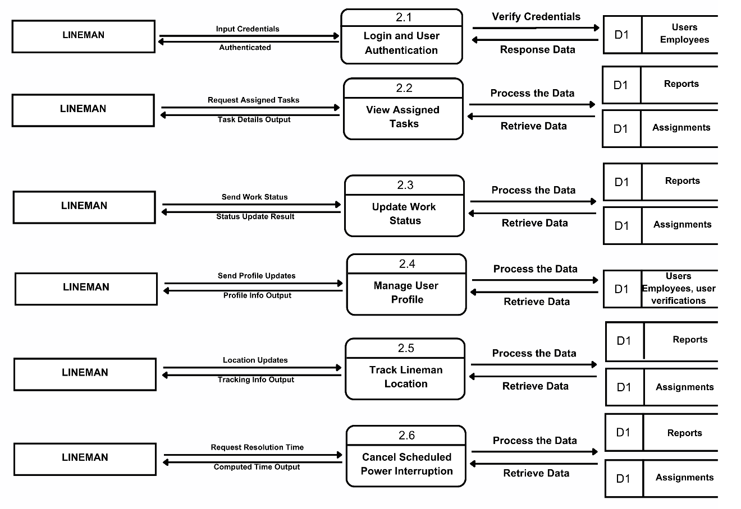
Figure 17 showed the data flow for a Lineman using the ISELCONNECT system. The system allowed the Lineman to perform core functions such as logging in, viewing assigned tasks, updating work status, managing their user profile, tracking lineman location, and handling scheduled power interruptions. These actions interacted with the system’s main data stores (D1), including Users/Employees, User Verifications, Reports, and Assignments.
The process began when the Lineman entered login credentials, which were verified against the Users/Employees database. After authentication, the Lineman viewed assigned tasks by querying the Reports and Assignments databases. As maintenance work progressed, the Lineman submitted work status updates, managed profile information, transmitted location updates, and requested resolution times, with these changes being processed through the corresponding data stores. This flow ensured that field operations and status updates were accurately synchronized with the central platform.
Figure 18: Data Flow Diagram (Resident) Level 3
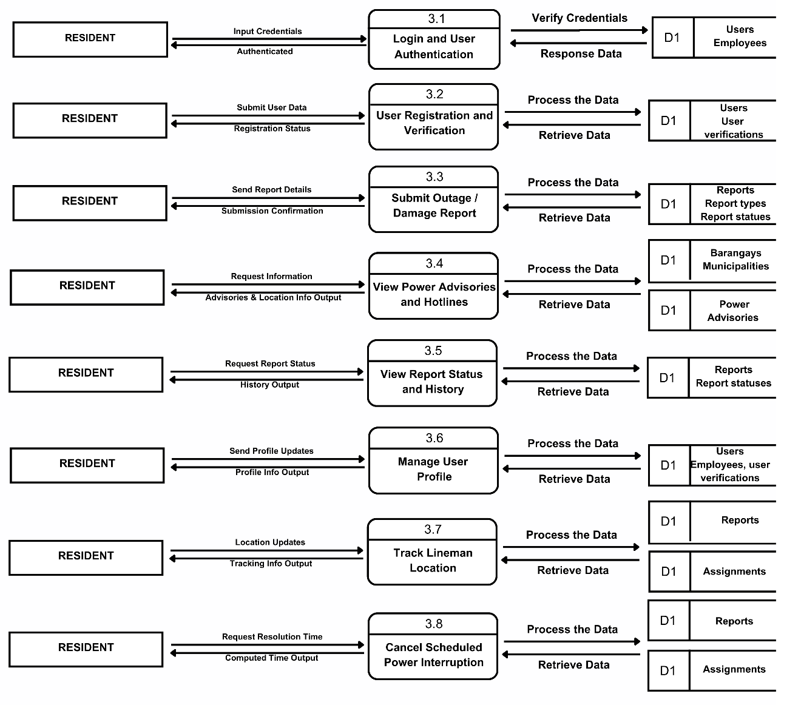
Figure 18 illustrated the data flow for a Resident using the ISELCONNECT system. The system allowed the Resident to engage through several primary processes: user authentication, registration and verification, submitting outage or damage reports, viewing power advisories and hotlines, viewing report status and history, managing user profiles, tracking lineman location, and handling scheduled power interruptions. These actions interacted with the system’s main data stores (D1), including Users/Employees, User Verifications, Reports, Report Types, Report Statuses, Barangays/Municipalities, Power Advisories, and Assignments.
The process began when the Resident entered login credentials, which were verified against the Users/Employees database. After authentication, the Resident could submit registration details for verification, send outage or damage reports to the Reports database, view power advisories and location info, check report history, manage profile information, track lineman locations, and request resolution times for scheduled power interruptions. This flow highlighted how ISELCONNECT facilitated residents in reporting utility issues and monitoring maintenance status efficiently.
Figure 19: Data Flow Diagram (Branch Administrator) Level 4
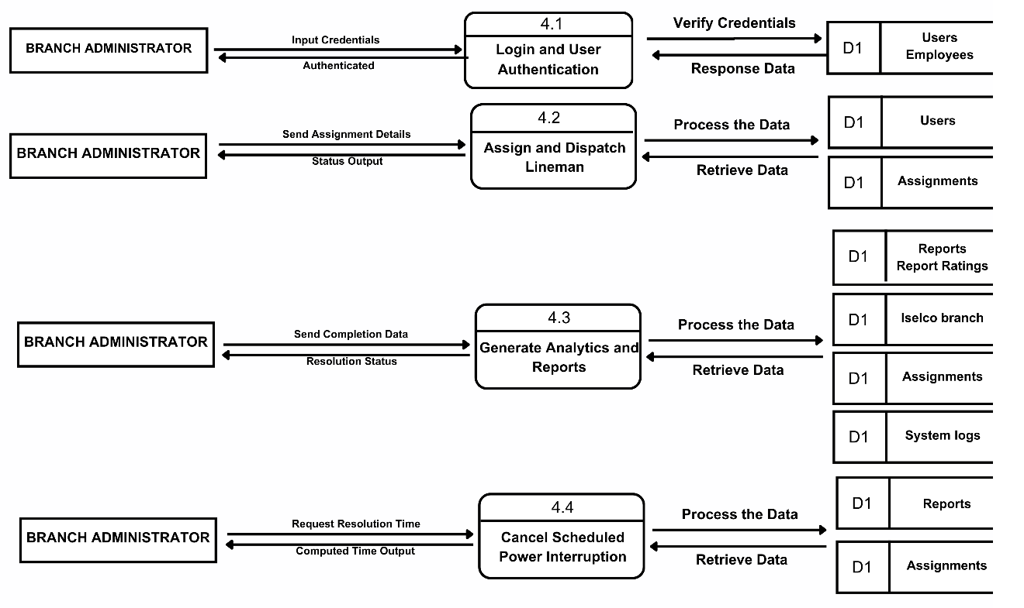
Figure 19 presented the data flow for a Branch Administrator using the ISELCONNECT system. The system allowed the Branch Administrator to log in, assign and dispatch linemen, generate branch analytics and reports, and manage scheduled power interruptions. These functions interacted with various data stores (D1), including user credentials, assignments, reports, branch records, and system logs.
The process began when the Branch Administrator entered their login credentials, which were validated against the Users database. After authentication, the Branch Administrator managed task allocations by submitting assignment details to the Assignments database. The Branch Administrator also generated analytics and reports by querying branch and system data stores and handled power interruption requests by accessing the Reports and Assignments databases. This flow highlighted how the Branch Administrator played a vital role in local operations management, field dispatching, and regional reporting.

4.6.3 Entity Relationship Diagram (ERD)
Figure 20: Entity Relationship Diagram of the proposed system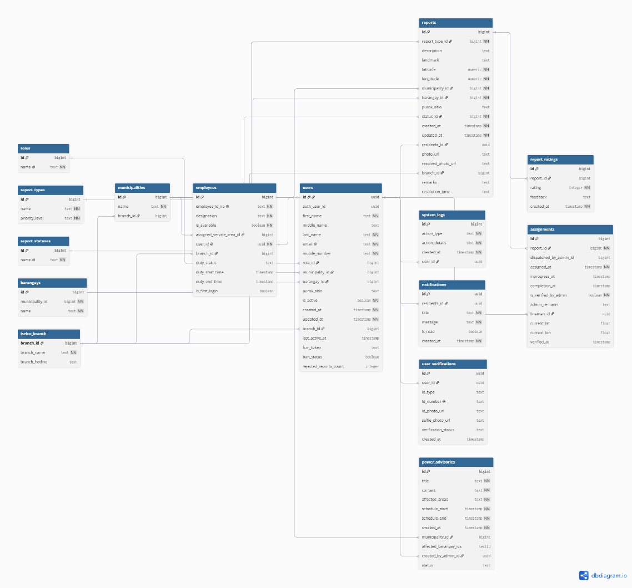

Figure 20 presented the Entity Relationship Diagram (ERD) of ISELCONNECT that outlined the database structure of the system. The ERD visually represented the system’s entities and their relationships, serving as a clear blueprint for efficient data organization, management, and retrieval.
Table Relationships Discussion
The ISELCONNECT uses a normalized relational database to ensure accuracy, integrity, and scalability. Its structure reflects
The users table served as the primary repository for personal and login information, enabling role-based access by linking to the roles table and maintaining geographic consistency through connections to the municipalities and barangays tables.
The employees table stored professional data for staff members and was directly linked to the users table, allowing the system to track worker-specific details such as employee_id_no, designation, assigned_service_area_id, last_known_lat, and last_known_long for efficient dispatching.
The report_types table defined various utility issues, categorized by names and a priority_level, ensuring uniform classification and helping administrators prioritize urgent repairs.
The reports table recorded every utility incident and served as the main point of integration, containing foreign keys like residents_id to users.id, report_type_id to report_types.id, and status_id to report_statuses.id to make each case fully traceable with details like landmarks, purok/sitio, and precise GPS coordinates.
The assignments table managed the dispatching process by linking a report to a specific lineman, tracking the workflow through timestamps such as assigned_at, inprogess_at, completion_at, and I and incorporating administrative verification via is_verified_by_admin and admin_remarks.
The system_logs table ensured accountability by tracking all system activities, recording every action performed by a user_id, capturing an action_type and action_details to provide a full history of operations.
The power_advisories, and hotlines tables managed public information and safety, where advisories linked to a created_by_admin_id and specified affected areas to push targeted information to residents.

